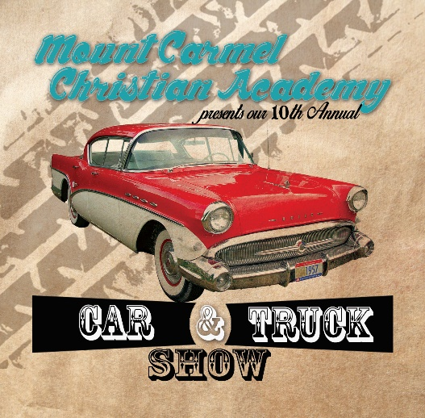
Mt. Carmel Christian Academy’s
11th Annual Car & Truck Show
Sponsorship Form

2331 U.S. Highway Bsn 340
Luray, VA 22835
(540) 743-9558

September 21, 2019, 10a.m. – 3p.m.

Thank you for being a sponsor for our event! All donations are tax-deductible and must be received no later than August 31, 2019. Every dollar raised goes directly to Mt. Carmel Christian Academy. We are looking forward to another fun, family event.
Please fill out the information below.

Business or Individual’s Name:________________________________________________________
Contact Person:_____________________________________________________________________
Email: ________________________________________Phone Number: _______________________

Select donation level | Donation Amount | Sponsor Receives…. | T-shirt size(s)
□ | $500 or more | - Logo displayed on all 2019 MCCA Car & Truck Show t-shirts (one color, size determined by donation and designer layout)  - One free t-shirt for every $100
□ | $100-$499 | - Name only on all 2019 MCCA Car & Truck Show t-shirts (one color, no phone or address)  - One free t-shirt for every $100

For MCCA representative use only:
□ Confirm name as it will appear on t-shirts____________________________________________
□ Logo on file □ Logo to be emailed to info@mcrbc.org
□ Donation received: Amount___________Check No. (payable to MCCA) _________Check Date _______________

